Nicholas Sammut

Dr. Mark Allison

CIS 525

**Extra Credit**

Screenshot of Emulator

On Application Opening

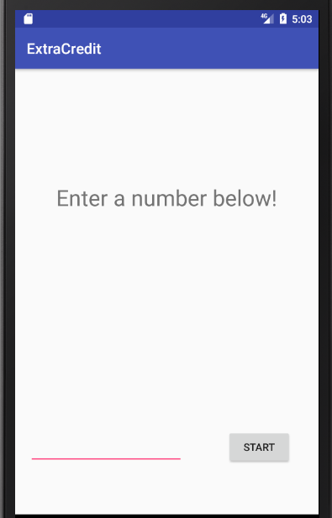

A Few Seconds After 7 Is Entered And Start Is Pressed

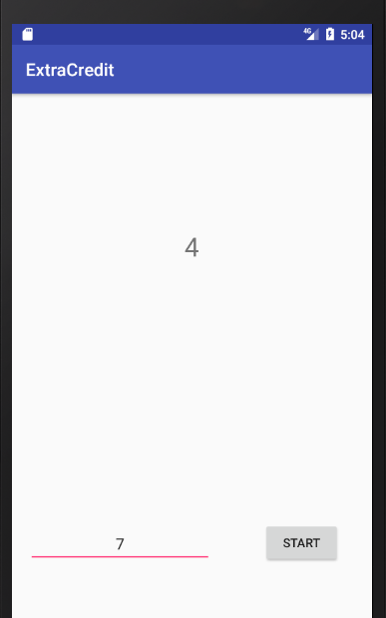

Countdown Complete

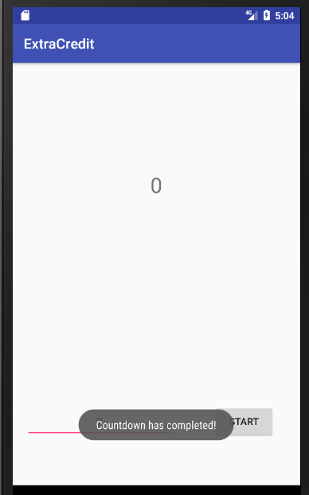

Java File

